TITLE | Unification algorithm
PROBLEM STATEMENT / DEFINITION | Implementation of Unification algorithm
OBJECTIVE | To apply Unification algorithm for First Order Logic.
S/W PACKAGES AND  HARDWARE APPARATUS USED | - Operating System : Latest version of 64 –Bit operating systems open source Fedora 20 or higher equivalent or Windows 8 with Multicore CPU equivalent to Intel i5 / 7 generation onwards  - Debian based OS ( Ubuntu 13.04 ) , g ++ , Python 2.7  - Programming Tools : Latest 64 –Bit Programming languages such as Microsoft Visual Studio ( ver. 12 or Higher ) or equivalent open source , Eclipse / QT 64 –Bit platform / IDLE editor  - 32 / 64 –bit LATXT
REFERENCES | http://basics.sjtu.edu.cn/seminars/c_chu/Algorithm.pdf
STEPS | Refer to theory, algorithm, test input, test output
INSTRUCTIONS FOR  WRITING JOURNAL | - Date  - Assignment no.  - Problem definition  - Learning objective  - Learning outcome  - Related Mathematics  - State transition diagram  - Concepts related Theory  - Program code with proper documentation.  - Output of program.  - Conclusion and applications (the verification and testing of outcomes)

Assignment No. 4

- Aim
Implementation of Unification algorithm

- Prerequisites
- Preposition and predicate logic
- First Order Logic (FOL)

- Learning Objectives
- Understanding the need for unification.
- Understanding First order theorem.
- Defining alphabets, terms, and substitutions

- Learning Outcome
- Ability to deal with First order logic
- Assigning a symbolic value to each variable of the problem’s expressions
- To learn use and implementation of unification algorithm.

- Concept
Representation of knowledge:
In order to solve the problems encountered in artificial intelligence , one needs both large amount
of knowledge and some mechanisms for manipulating that knowledge to create solutions to new
problems.
A variety of ways of representing knowledge (facts) have been exploited in AI programs.

Two kinds of entities:
1. Facts: truths in some relevant world
2. Representations of facts in some chosen formalism: These are the things we will actually be able to manipulate.
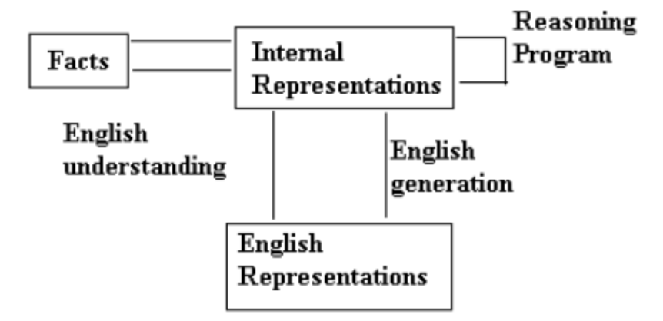
Fig 1: Mapping Between Facts and Representations.

The knowledge level, at which facts are described and the symbol level at which representations of objects at the knowledge level are defined in terms of symbols that can be manipulated by programs.

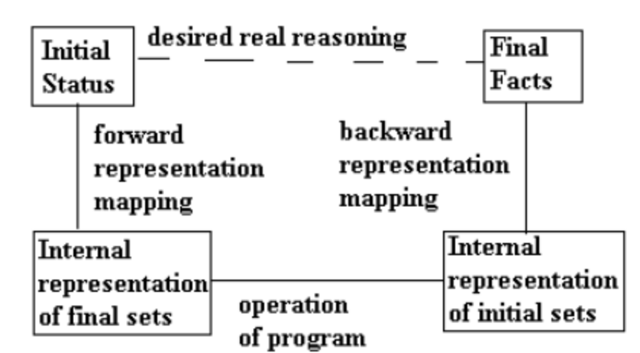
Fig 2: Representations of facts

Figure 2 is an expanded view of the figure 1.

The dotted line across the top represents the abstract reasoning process that a program is intended to model. The solid line across the bottom represents the concrete reasoning process that a particular program performs

Issues in knowledge representation:
- Are many attributes of objects so basic that they occur in almost every problem domain? If there are, we need to make sure that they are handled appropriately in each of the mechanisms we propose. If such attributes exist, what are they?
- Are there any important relationships that exist among attributes of objects?
- At what level should knowledge be represented? Is there a good set of primitives into
- which all knowledge can be broken down?

Is it helpful to use such primitives?
- How should sets of objects be represented?
- Given a large amount of knowledge stored in a database, how can relevant parts are accessed when they are needed?

Properties of Attributes:
  - Inverses
  - Existence in an isa hierarchy
  - Techniques for reasoning about values
  - Single-valued attributes.

Properties of internal representation:
      - Representational adequacy: The ability to represent all of the kinds of knowledge that are needed in that domain.
      - Inferential adequacy: The ability to manipulate the representational structures in such a way as to derive new structures corresponding to new knowledge inferred from old.
      - Inferential efficiency: The ability to incorporate into the knowledge structure additional information that can be used to focus the attention of the inference mechanisms in the most promising directions.
      - Acquisitional Efficiency: The ability to acquire new information easily. the simplest case involves direct insertion , by a person , of new knowledge into the database . Ideally, the program itself would be able to control knowledge acquisition.

Resolution, Resolution in predicate logic.
The resolution procedure is a simple iterative process: at each step, two clauses called the parent clauses are compared (resolved) , yielding a new clause that has been inferred from them. The new clause represents ways that the two parent clauses interact each other. Suppose that there are two clauses in the system.
winter V summer
-winter V cold
Recall that this means that both clauses must be true.
Now we observe that precisely one of winter and -winter will be true at any point. If winter is true, then cold must be true to guarantee the truth of the second clause. If -winter is true, then summer must be true to guarantee the truth of the first clause . Thus we see that from these two clauses we can deduce summer v cold.
This is the deduction that the resolution procedure will make.
If the clause that is produced is the empty clause, then a contradiction has been found.
For example, the two clauses
Winter
-winter will produce the empty clause. If a contradiction exists, then eventually it will be found.

The theoretical basis of the resolution procedure in predicate logic is Herbrand’s theorem, which tells us the following:
- To show that a set of clauses S is unsatisfiable, it is necessary to consider only interpretations over a particular set, called the Herbrand universe of S.

A set of clauses S is unsatisfiable if and only if a finite subset of ground instances of S is unsatisfiable.
We now have an easy way of determining that two literals are contradictory –they are if one of them can be unified with the negotiation of the other.

So, for example, man(x) and –man (Spot) are contradictory, since man(x) and man (Spot) can be unified. This corresponds to the intuition that says that man(x) cannot be true for all x if there is known to be some x, say Spot, for which man(x) is false. Thus in order to use resolution for expressions in the predicate logic, we use the unification algorithm to locate pairs of literals that cancel out.

We also need to use the unifier produced by the unification algorithm to generate he resolvent clause. For example, suppose we want to resolve two clauses:
1. man (Marcus)
2.-man(x1) V mortal(x1)
The literal man (Marcus) can be unified with the literal man (x1) with the substitution Marcus/x1. Telling us that for x1=Marcus,-man (Marcus) is false. But we cannot simply cancel out the two man literals as we did in propositional logic and generate the resolvent mortal(x1). Clause 2 says that for a given x1, either –man(x1) or mortal(x1). So for it to be true, we can now conclude only that mortal (Marcus) must be true. It is not necessary that mortal(x1) be true for all x1, since for some values of x1, -man(x1) might be true , making mortal(x1) irrelevant to the truth of the complete clause. So the resolvent generated by clauses 1 and 2 must be mortal (Marcus), which we get by applying the result of the unification process to the resolvent. The resolution process can then proceed from there to discover whether mortal (Marcus) leads to a contradiction with other available clauses.

Resolution Algorithm for Predicate Logic
- Convert all the statements of F to clause form.
- Negate P and convert the result to the clause form. Add it to the set of clause obtained in step 1.
- Repeat until a contradiction is found, no progress can be made, or a predetermined amount of effort has been expanded.
  - Select two clauses. Call these the parent clauses.
  - Resolve them together. The resolvent will be the disjunction of all the literals of both parent clauses with appropriate substitutions performed and with the following exception: if there is one pair of literals T1 and –T2 such that one of the parent clauses contains T1 and the other contains T2 and if T1 and T2 are unifiable, then neither T1 nor T2 should appear in the resolvent. We call T1 and T2 complementary literals. Use the substitution produced by the unification to create the resolvent. If there is more than one pair of complementary literals, only one pair should be omitted from the resolvent.
  - If the resolvent is the empty clause, then a contradiction has been found. If it is not, then add it to the set of clauses available to the procedure.

Unification algorithm
Algorithm: Unify (L1,L2)
- If L1 or L2 are both variables or constants then:
  - If L1 and L2 are identical, then return NIL.
  - Else if L1 is a variable, then if L1 occurs in L2 then return {FAIL}, else return (L2/L1).
  - Else if L2 is a variable then if L2 occurs in L1 then return {FAIL}, else return (L1/L2).
  - Else return {FAIL}
- If the initial predicate symbols in L1 and L2 are not identical, then return {FAIL}.
- If L1 and L2 have a different number of arguments then return {FAIL}.
- Set SUBST to NIL. (At the end of this procedure, SUBST will contain all the substitutions used to unify L1 and L2).
- For I ← 1 to number of arguments in L1:

  - Call unify with the ith argument of L2, putting result in S.
  - If S contains FAIL then return (FAIL).
  - If S is not equal to NIL then :
    - Apply S to the remainder of both L1 and L2.
    - SUBST: = APPEND (S, SUBST).
- Return SUBST.

Example:
Consider unifying the literal P(x, g(x)) with:
- P(z,y) : unifies with {x/z, g(x)/y}
- P(z, g(z)): unifies with {x/z} or {z/x}
- P(Socrates, g(Socrates)) : unifies, {Socrates/x}
- P(z, g(y)): unifies with {x/z, x/y} or {z/x, z/y}
- P(g(y), z): unifies with {g(y)/x, g(g(y))/z}
- P (Socrates, f (Socrates)): does not unify: f and g do not match.
- P(g(y), y) : does not unify: no substitution works

- Mathematical Model:
Let S be the system set:
S = {s, e, X, Y, Fme, Fc, Sc} where
s=start state i.e taking symbols from user e=end state i.e. finding substitution.
X=set of inputs
X = {X 1, X2}
where
X1 = {nop}
nop=number of predicates.
X2 = {P 1, P 2, P 3....Pnop}
where Pi={a1, a2....an}
ai=argument
Y=set of outputs
Ys = {1, 0}
where
1= substitution created.
0=substitution not created
Fme is the set of main functions
Fme = {f pred , farg , funify }
where
fpred = taking predication from user.
funify = checking unification
Sc = success case:
Substitutions created
successfully.
Fc =failure case:

If number of arguments are different
If predicated have same arguments

- Conclusion:
Thus, after successfully completing this assignment, you should be able to understand & implement unification algorithm for first order logic.

